**REC RAMBLER**

The Recreation department is offering a single day field trip program for kids that are going into 6th, 7th, and 8th grades named *REC RAMBLERS.*

Rec Rambler is great for groups of kids that would like to go together! Fantastic for parents that might not have time to go to all these places in the summer!

The program will pay for transportation and entry into field trips. Participants will be responsible for food purchases and any extras they would like. Weekly pricing will differ based on field trip costs, time, distance, etc.

The rec center staff will take and chaperone your children to and from the field trip each week. This will not be one on one supervision. Staff will set up meeting times throughout the day as well as acquiring everyone’s phone number for easy contact. Campers will have freedom to go on their own if they are showing responsibility. Campers are released when returning to the rec center.

Registration in person March 3-31 for current BASP or past summer camp or Rec Rambler participants. The public can enroll April 1at 6AM online.

**June 12 Lost Island Theme ($60)**

**June 19 Fun City ($50)**

**June 25(W) Cedar Rapids Kernels ($20)**

**July 3 Clear Creek Paintball ($70)**

**July 10 Yogi Bear Jellystone Water ($50)**

**July 17 Lost Island Water ($60)**

**July 24 Coral Ridge Mall/Movie ($20)**

**July 31 AIRFX ($40)**

**Aug 7 Clear Creek Paintball ($70)**

**Aug 14 Dragons Lair ($30)**

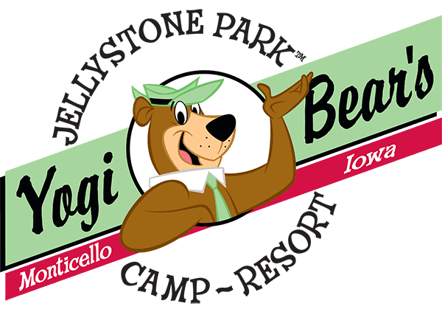

**Please fill out emergency information and sign code of conduct form on back**

**Rec Ramblers PARTICIPANT EMERGENCY INFORMATION FORM**

Child’s name: _____________________________________________________

Parent’s name: ____________________________________________________

Home phone: _____________ Mom’s/Dad’s Work phone: _________________

Child’s School: _____________________ Child’s Cell Phone: ________________

Parent’s Email______________________________________________________

In case of emergency, and parents cannot be reached; Notify the following:

Name: ___________________________ Phone: ______________________

* Campers shall be responsible for their words and actions.
* Campers shall be respectful of others. No bullying or acts of violence.
* Endangering the health and safety of themselves, other campers, and staff
* Stealing, damaging, or failing to care for property not belonging to child.
* Continual disruption of the program or refusal to follow the guidelines.
* Inappropriate physical contact
* Using profanity or inappropriate language or displaying clothing or other personal items with offensive content.
* Possession or use of illegal substances, tobacco, or alcohol. Possession of weapons
* Campers shall follow directions from staff members.

The Rec Center reserves the right to remove participants for not following our set guidelines at any time with no refund given.

Camper: By signing this form, I agree to follow the above guidelines. I understand that more specific rules will be explained to me when I arrive. I also realize that failing to follow these guidelines will result in disciplinary action and may include removal from the program.

**Camper’s Signature: ______________________________________ Date: ________________** Parent(s)/Guardian(s): By signing this form, I am acknowledging that I read the guidelines with/to my child.

**Parent/Guardian Signature: ________________________________Date: _________________**

This form MUST be completed and turned in prior to your child’s attendance at camp.